

VIVID SEATS BULK UPLOAD TUTORIAL

Introduction

Our new Bulk Seller Upload function at Vivid Seats is set to provide you with a new and revolutionary way to personally upload your inventory to our site with guaranteed safety and efficiency. For your inventory to be uploaded in bulk you must first set up a Vivid Seats account. Next, you will email bulksellers@vividseats.com with your intent to become a bulk seller (please include your user name/email and contact information). Once you have been approved, your Vivid Seats profile will display a ‘Bulk Seller Upload’ option. Click on that option to begin uploading your inventory. In the ‘Seller Information’ area, fill out the default ticket location and default credit card information and if applicable update your PayPal address. To begin uploading your tickets, create your personal comma delimited (csv) file that contains detailed information about your inventory such as event, venue, section and price.

This document will walk you through:
- Creating a bulk upload excel spreadsheet
- Entering product information
- Saving the file as a comma delimited .csv file
- Submitting the data to Vivid Seats

We recommend you read through this complete document before starting the process of creating your inventory upload.

Creating an Excel Spreadsheet

Through Microsoft Excel, create a workbook that has the following 13 columns
The template should look exactly like this (with your inventory filled in):

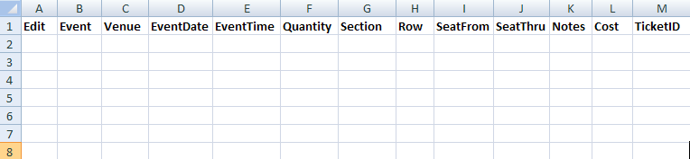

The Spreadsheet contains 13 columns and must be filled out accurately:

- Edit  - Event  - Venue  - Event Date  - Event Time  - Quantity  - Section  - Row  - Seat From | - Seat Thru  - Notes  - Cost  - Ticket ID

Entering Product Information

There must be exactly one product per row with the first product starting on row 2 (row 1 contains the column headers). Do not skip any rows.

For each product, you must provide the following 13 pieces of information:
- Edit (Y/N)
- Event
- Venue
- Event Date
- Event Time (Leave blank if unknown)
- Quantity
- Section
- Row
- Seat From (Optional)
- Seat Thru (Optional)
- Notes (Optional)
- Cost (Sales Price)
- Ticket ID (Optional)

Example of a CSV File:

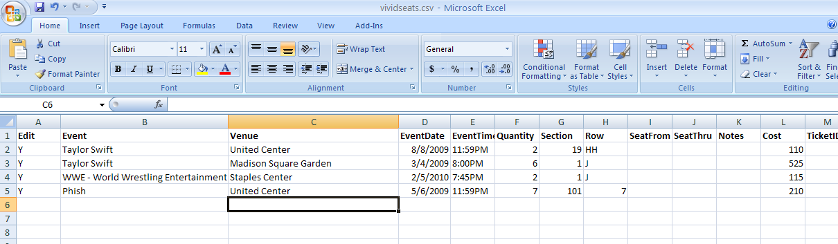

Providing as much information as you can will ensure that consumers make more informed decisions before visiting the Vivid Seats website. However, if you do not have information for a field, leave that field completely blank. Do not delete the column. Your spreadsheet must contain all 13 columns, even if they do not contain any data.

Edit
- This column refers to whether or not it is an Active or Inactive Listing.
- Input a Y in the column for Active or a N for Inactive

Event
- Specify the precise name of the event

Venue
- This is the name of the Venue that will host the event

Event Date
- Specify the Event Date

Event Time
- Specify the Event Time
- If you don’t know the event time, leave this column blank.
- **This is very important for events that show multiple times per day**

Quantity
- The number of tickets you have for the event

Section
- The Section your ticket(s) are in, as printed on the ticket(s).

Row
- The Row your ticket(s) are in, as printed on the ticket(s).

Seat From (Optional)
- Use this field to designate the beginning seat number

Seat Thru (Optional)
- Use this field to designate the ending seat number

Notes (Optional)
- This field is your opportunity to include any specific notes about the tickets (i.e. aisle row, handicap seats etc.)
Cost
- The Sales Price per ticket

Ticket ID (Optional)
- Indicate your own Ticket ID number.
Saving the File

When you are finished entering your product information, save your spreadsheet in Comma Delimited .csv format:

To save the file in Excel:

- On the top menu, click File, and then Save As…

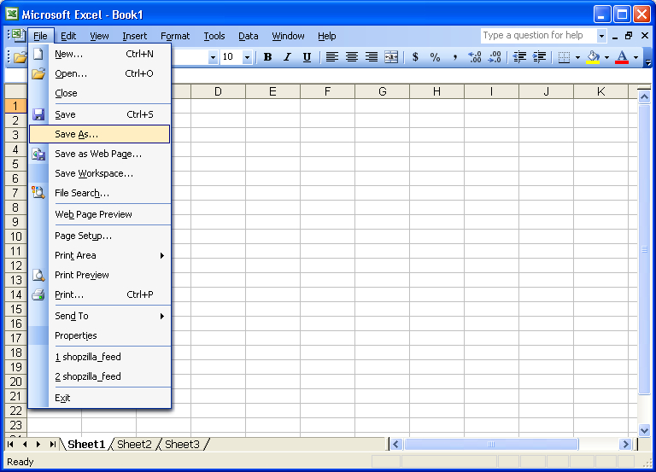

- At the top, in the “Save In:” box; make sure your file is saved in a readily available location on your computer (for example, My Documents or Desktop). Then, name your file yourname.csv in the “File name:” box, and in the “Save as type:” drop-down menu, choose CSV (Comma delimited). Then click the “Save” button.

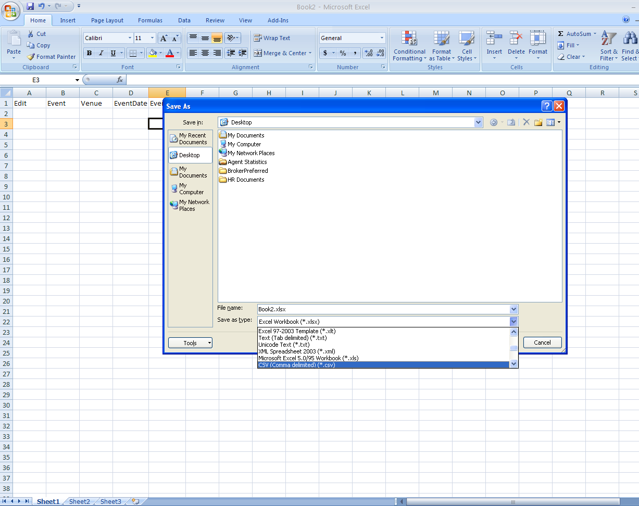

**You are now ready to Bulk Upload your inventory to Vivid Seats! **
Bulk Uploading your Inventory

- To Bulk upload your inventory, log into your Vivid Seats account and click on the "Bulk Seller Upload" option.
- Enter your default ticket location and set the default credit card information.
- Click ‘Browse’ next to File Location and find your csv file on your computer.
- Make sure that Overwrite all current listings is checked.
- Agree to the Vividseats.com seller terms and conditions by checking the box.
- Click ‘Upload Tickets’.

**For specific information on FTP Server Uploading options email bulksellers@vividseats.com

Payment

Payment for your inventory will be by either PayPal or Check and will be received 7 days after the customer receives the tickets

Contact Us

If you have any questions or concerns, please contact bulksellers@vividseats.com

